1(c) Setting some Fourier coefficients to 0 basically is removing them from the estimation. Therefore, by the graph, we can see that the orange line representing the Fast Fourier Transformation of the original graph, which we only keep first 10% of the Fourier coefficients. We can see that the FFT graph is matching the original data in most of the part but with smoother turns.
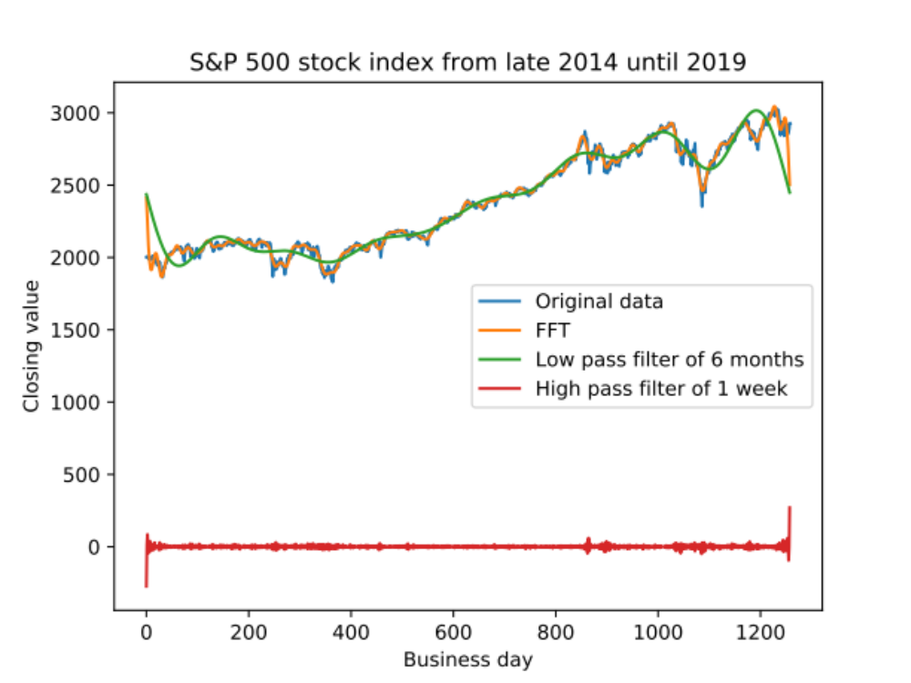
1(d)
The green curve shows the low-pass filter. The low-pass filter graph is clearly losing more detail since we delete all the components with period less than 6 months. The shape is smoother than FFT but the estimation is more ambiguous.
1(e)
The red line is the high-pass filter. It looks like the some background noises since we set the main functions to zero. The rest of the components are just some small adjustment on the detail of the graph. Therefore it doesn't show any main shape of the function but rather a straight line.

